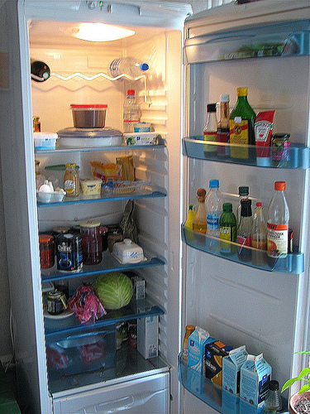*We don’t eat to live,*

*we live to eat.*